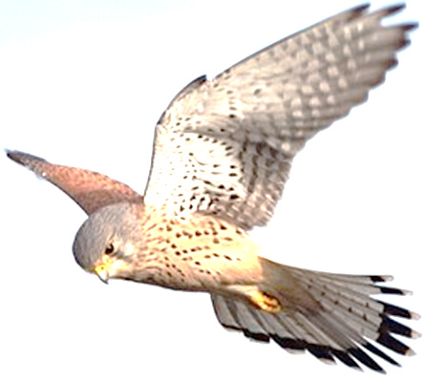

New Zealand
Aeronautical Trust Limited
Awards Nomination Form
Nominations will only be considered if submitted using this nomination form.
NOTE: This form is to be completed and submitted electronically. Once the nominator has completed the relevant sections, please save the file with the nominee name as the file name and email on to the referee so that they may complete their relevant section. A signature is not required.

Please, DO NOT print, sign, and then scan this form. DO NOT save as a PDF.
New Zealand Division Award:
Meritorious Service Award. The Meritorious Service Award is made by the Council of the Society and recognises long term contributions and practical achievements in all sections of aerospace in New Zealand
New Zealand Aeronautical Trust Ltd. Awards:
Douglas Patterson Award. This award is to encourage those persons who are making a career in aviation in South Pacific countries. The award is intended to assist the candidate to gain experience in the aviation industry in New Zealand or overseas.
Duncan Campbell Award. This award comes in two categories:
Category A: To encourage any person showing potential in the profession of Aviation Journalism. Candidates must be under 28 years of age at the time of the application.
Category B: To recognise established Aviation Journalists or Writers who have demonstrated their ability and dedication in this specialised area.
EA Gibson Award. This award recognises the contribution of the first Director of Civil Aviation, Mr E.A. Gibson (Gibby) to the establishment of civil aviation and particularly his support for the establishment of the agricultural aviation sector in New Zealand. This award is for innovation or another form of excellence within the field of agricultural aviation in New Zealand.
Geoffrey Roberts Award. This award is open to any young person, a New Zealand citizen, who has the firm intention of following a career in civil aviation in New Zealand. At the time of selection, the candidate could be in training in preparation for taking up such a career or could be gaining experience in civil aviation overseas.
Henry Wigram Award. This award honours the name of the politician who was instrumental in the establishment of military aviation in New Zealand in the early part of the last century. The award is made for the best paper delivered to a branch of the Society, or at a symposium.
Ian J Diamond Award. This is made to a young aviation professional wishing to embark on a course of higher academic study leading to a degree in an aviation related subject and with the firm intention of participating in New Zealand aviation.
Michael J Neville/Boeing Airplane Company Award. This award is made to a young person working in aviation in New Zealand who demonstrates excellence in work ethics, values, application and results, and has a firm and appropriate intention for further study or learning.
.

Award name
Award type
(Individual or team)

Nominee/Team Leader Information
Nominee Name
Team Title
(Applicable only to Team Award)
Organisation
Job Title:
Address
Email
Telephone

Summary of Specific Achievements - short (up to 100 words)
Please provide a single sentence less than 100 words, which describes the specific achievement on which this nomination is based. This may be used in publications if the nomination is successful.

Detailed Specific Achievements - expanded (up to 500 words)
Describe the advances or contributions made by the individual or team nominated (500 words maximum). Please refer to previous awards posted on the RAeS NZ Division website for the style of writing.
This section will form the ‘citation’, which will be presented, along with the certificate accompanying the award, to the nominee. Please aim to have the words of this section fit on 3/4 page of A4 (maximum). You can expand this section as required to accommodate the text.

Nominee Career History
Please give details of the nominee’s career history, including dates, positions held, and nature of responsibility.
In the case of a team nomination, please detail the history of the team’s collaboration, including dates, positions held, nature of responsibility, and names of key team members being nominated.
If this information is to be submitted within a separate attachment, please enter the details of attached documents.

Nominator Information
Nominator Name
Organisation
Job Title:
Address
Email
Telephone

I hereby certify that the above information is true and correct to the best of my knowledge.
I acknowledge that the RAeS NZ Division may contact me to verify the information, as required.
Date

Independent Referee Information
Referee Name
Organisation
Job Title:
Address
Email
Telephone

Referee Endorsement:

I hereby certify that the above information is true and correct to the best of my knowledge.
I acknowledge that the RAeS NZ Division may contact me to verify the information, as required.
Date

Nomination forms are to be submitted by email to David Saunders
Email: hengeart2@gmail.com
File formats : Save as .doc or .docx (Do not PDF)

