FLY BY
June 2025 NEWSLETTER of the PALMERSTON NORTH BRANCH NEW ZEALAND DIVISION ROYAL AERONAUTICAL SOCIETY
______________________________________________________________________

It has been a quiet month again. Our guest speaker for the may meeting had to defer and will now visit us for our July meeting

Maurice Job addressed the meeting as a fill-in on the subject of ‘Model Aircraft and Drones in New Zealand Airspace’ which explained much of the regulatory environment resulting from the impact of readily available drones on the world wide market and the resulting limitations imposed on model aircraft fliers.

We also discussed the monthly raffle. I has been suggested that an “annual ticket” be available to simplify Jeff’s task and avoid the need to carry coins. This was generally agreed, members would ‘purchase’ a number for the financial year and would be in the draw each month whether they were in attendance or not. It was further agreed that this would be difficult to start now; part way through the year, so would commence at the start of the new financial year.

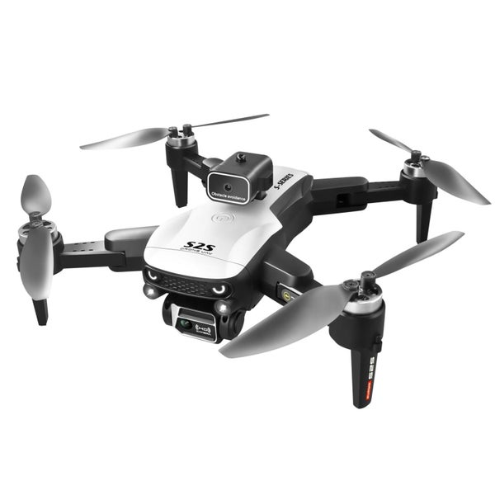
A drone Not a drone
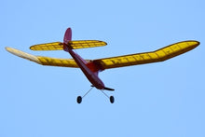
The recent attack by Ukraine on Russian airbases over hundred of kilometres distant, shows how far UAVs, or RPVs have developed so that they have become a potent tool of war. These were apparently “flown” by pilots remotely from bases using on board cameras and data via links; a further development of the FPV (First Person View) I discussed at the May meeting

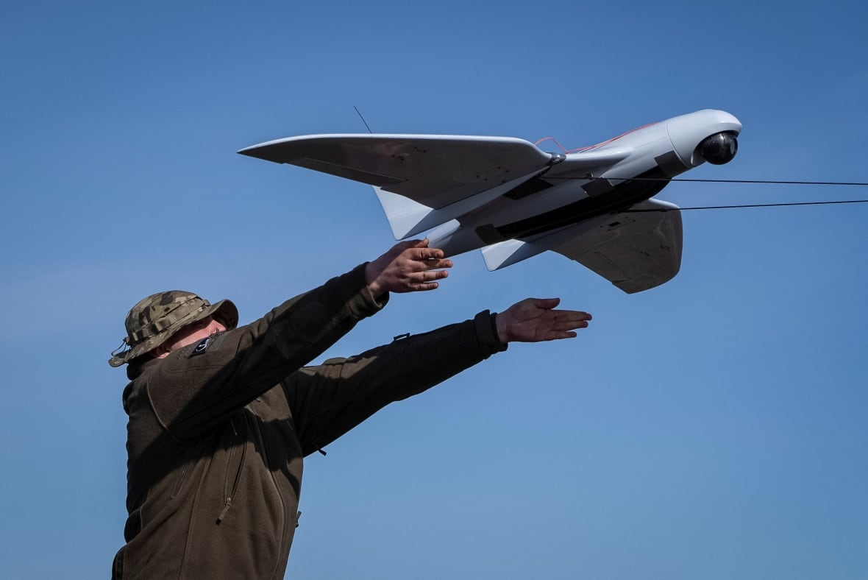
Ukraine attack drone similar to that used in raid on Russia

June BRANCH MEETING
We are at our usual venue – the Massey School of Aviation.
Meeting at 1900 Tuesday 10th June.

Our speaker this month is John Brooks, who is a retired professor and introduced the use of unmanned aerial vehicles to some of his colleagues at Auckland University of Technology, as an alternative to the cost of satellite images for research purposes. John is a Class 3 glider engineer and the CFI of Gliding Manawatu.

John’s subject will be "Taylor Valley Traffic: Fox UAV is airborne". It is a combination of a travelogue and a technical presentation.
I look seeing as many members as possible, and join us for a coffee afterward,

Maurice Job,
Branch Chairman
mauricej@inspire.net.nz
Phone (021) 670689

