FLY BY
August 2025 NEWSLETTER of the PALMERSTON NORTH BRANCH NEW ZEALAND DIVISION ROYAL AERONAUTICAL SOCIETY
______________________________________________________________________

The Branch July meeting was addressed by Squadron Leader Grant Te Tau who is Unit Commander of No 32 (Borough of Feilding) Squadron Air Training Corps. Grant covered the purposes and goal of Air Training Cadets and his young people described how the activity increased their self confidence. A good presentation.

A recent FB post by Brendon Deere follows:
Our long-term temporary resident, Aermacchi MB339CB NZ6472 has left us today for a new life in France with SDTS Services who already operate a number of ex RNZAF Aermacchis. The aircraft was originally allocated to the Masterton based Sport and Vintage Aviation Society which morphed into Wairarapa Flying Tigers and has been sold by them to SDTS. Engineers from that company will disassemble the aircraft for shipping. Note that although the Biggin Hill Trust has provided free hangarage for the aircraft for many years we have no involvement in the ownership or sale of this aircraft.

(photos courtesy Biggin Hill Historic Aircraft Centre, RNZAF Ohakea)

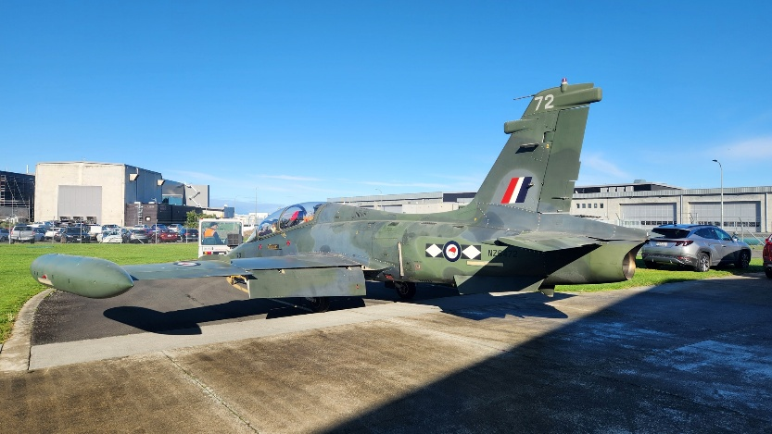
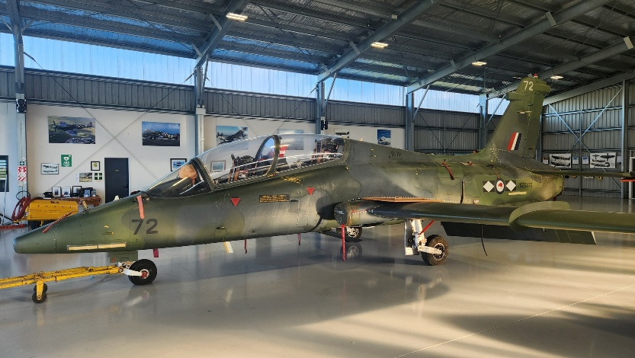

Secretary Barry sent me this photo which is interesting as it shows the new A4 Skyhawks being towed by road from wharves to their new home at Whenuapai in July 1970


(photo courtesy Air Force Museum of New Zealand)

For ‘Sale’
I have in my garage a VHS/DVD player, a screen (no projector) and stand and a pair of small speakers with an inbuilt amplifier. These were used by the Branch back when we met at the RSA and have been unused for many years. They can be obtained for a reasonable offer to Branch funds. Please contact me.


August BRANCH MEETING
We are at our usual venue – the Massey School of Aviation.
Meeting at 1900 Tuesday 12th July.

This month’s meeting will be hearing from David Lanham who will discuss some New Developments and Future Goals at PN Airport), with a focus on the Terminal Development Project which is currently underway.

David Lanham is the Chief Executive Officer at Palmerston North Airport Limited, having held the position since April 2014.

David has extensive international aviation experience in airport management, airline network & commercial planning, and airfreight management. He also has corporate experience in retail strategy and property development, and possesses technical skills in finance & accounting. Prior to joining Palmerston North Airport, David gained over 15 years of commercial aviation experience at Air New Zealand, Gulf Air (Bahrain), and as an aviation management consultant. David has worked on airline & airport assignments in Australasia, Asia, Africa, Middle East, and the South Pacific.

David’s commercial experience is supported by professional qualifications in finance and accounting. He is a certified practising accountant (CPA Australia), holds a First Class Honours degree in Finance from Massey University, Palmerston North, and a Masters in Practising Accounting from Monash University, Melbourne, Australia.

Join us for a coffee after the meeting,

Maurice Job,
Branch Chairman
mauricej@inspire.net.nz
Phone (021) 670689

Have You paid Your Subs Yet? Please make payment to the Branch Account
Royal Aeronautical Society 11-6900-0018393-11

