FLY BY
July 2025 NEWSLETTER of the PALMERSTON NORTH BRANCH NEW ZEALAND DIVISION ROYAL AERONAUTICAL SOCIETY
______________________________________________________________________

Winter is with us loud and clear, it’s late but the invasion of mice of late shows that the temperatures have dropped and food is in short supply.

The Branch June meeting was entertained by John Brookes with tales of his development and use of large UAVs doing survey work in Antarctica. The aircraft were developed and built by a Palmerston North business. They are capable of carrying a wide range of sensors and cameras

UAVs or drones are still very much in the news with the conflicts in the middle East and Ukraine. The Ukraine Ambassador to New Zealand has said that their drone technology would be available to our country and that we need it. From a purely cost basis, this line of thinking has much to recommend it. Small, low cost weapons systems would provide wide coverage for our extended and exposed coastlines. And Ukraine have been very successful with cottage industry assembling these weapons.

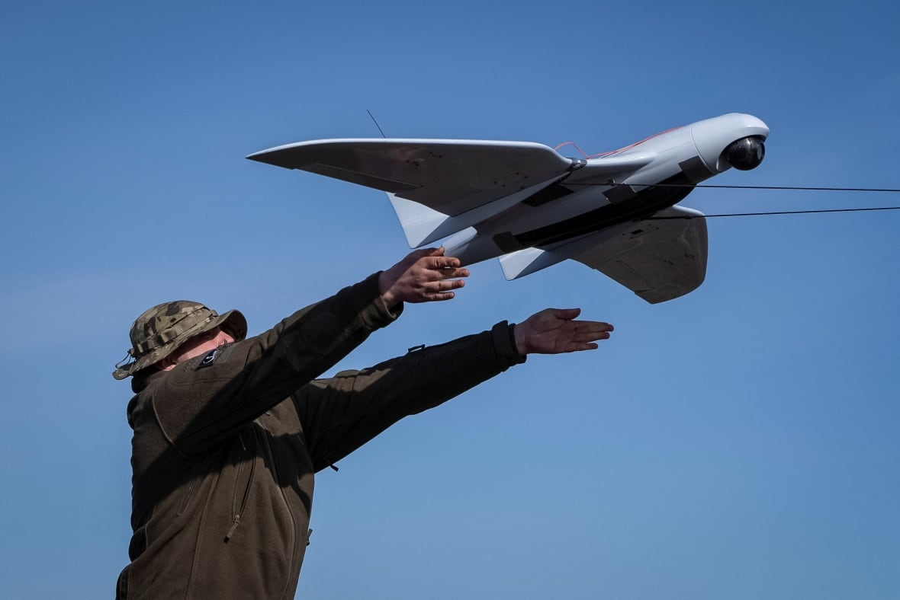
Ukraine attack drone similar to that used in the raid on Russia

Did anyone see the flypast by nine of the TexanII aircraft from Ohakea? It was a training flight for the instructors to polish their skills. These photos are as grainy as anything, but the planes were a long way from my place, and my shaky hands on the telephoto don’t help.

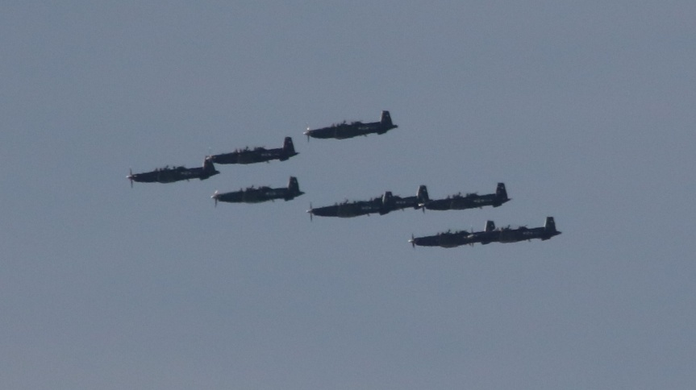

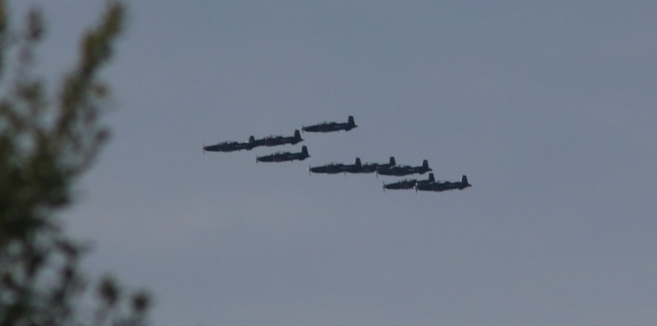

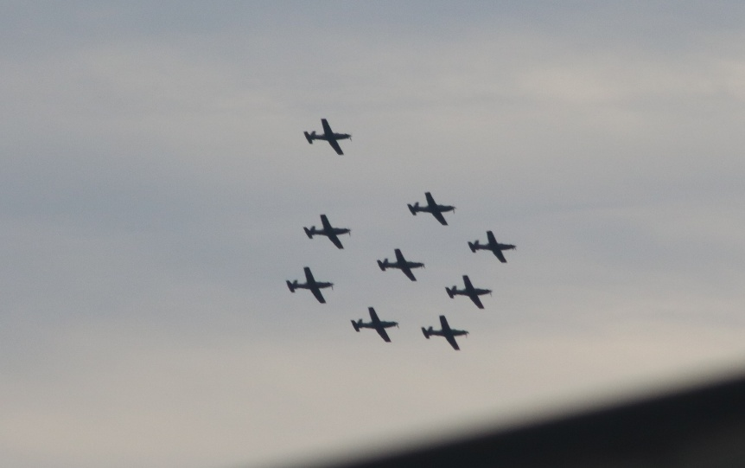

July BRANCH MEETING
We are at our usual venue – the Massey School of Aviation.
Meeting at 1900 Tuesday 8th July.

This month’s meeting will be addressed by Squadron Leader Grant Te Tau who is Unit Commander of No 32 (Borough of Feilding) Squadron Air Training Corps. Grant will cover the activities etc of the Squadron and our involvement with it. The Branch sponsors the unit to further flight experience for cadets at the Annual Camp
Unfortunately, another organisation for which I am the Treasurer, has scheduled its AGM for the same evening as the Branch meeting so I must tender my apology and leave the meeting in the capable care of Secretary Barry Heir.

Join us for a coffee after the meeting,

Maurice Job,
Branch Chairman
mauricej@inspire.net.nz
Phone (021) 670689



