FLY BY
October 2025 NEWSLETTER of the PALMERSTON NORTH BRANCH NEW ZEALAND DIVISION ROYAL AERONAUTICAL SOCIETY
______________________________________________________________________

Recently Steve Parsons, Barry Heir and I met to discuss and formulate the Branch’s input to the development at Milson Airport. David Lanham, the CEO of the Airport company had presented to the branch at the August meeting and asked for ideas on media and displays for the new terminal. Stephen had done a considerable amount of work and showed us a plan that covered the whole scope of media displays for the building. Our discussion became focussed on what the Branch would be particularly interested in seeing on display. We agreed that our focus would be on the historical significance of Milson to civil aviation in New Zealand. There is quite an amount of material available and some we already have. We also agreed that the use of dynamic digital displays rather than static physical displays was the way forward. Steve and I will present our ideas to the Branch at the October meeting.

The NZ Division web site has had a major revamp both in appearance and in functionality. I urge Branch and Society members to have a look at it.

The website is at https://aerosociety.nz/

As well as the new look, now Branches can directly post newsletters, news events etc on the web site, which makes it dynamic and more interesting and useful. The web site is under continuous development.

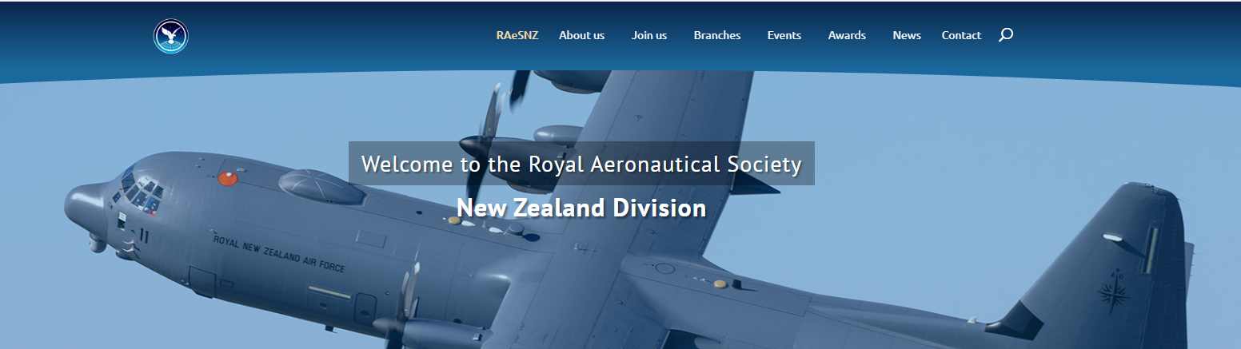

I am investigating all avenues as to how best the Branch can take advantage of the web presence. I already post news about coming meetings on the Palmerston North Facebook page.

All members should be aware that RAES Symposium is approaching. To be held on 31st October at Parliament, the theme this year is “Aviation in New Zealand’s Future” and all details are on the Division Website.

The new year is approaching, so I am on the lookout for Speakers for Branch meetings. A big thank you to those who have offered ideas for speakers this year, or offered to present themselves. It has been an interesting year with many excellent topics covered. If you have any ideas for the coming year, please let me know.

I recently received an email with this link for a video of a large model of F4 Phantom.
https://www.youtube.com/watch?v=Ck_b42PkY2c that is really worth the watch.

These “kits” by ‘CARF’ in the States are supplied largely prebuilt and painted to the customer’s order, require only final assembly. To a scale of 1:4.5 (approx. 22%) they span 2.64M and have a dry weight of around 37-40Kg. The twin turbines each deliver around 26Kg thrust and everything works; all flying surfaces, lights, retracts, canopies. These models cost approximately US$50,ooo

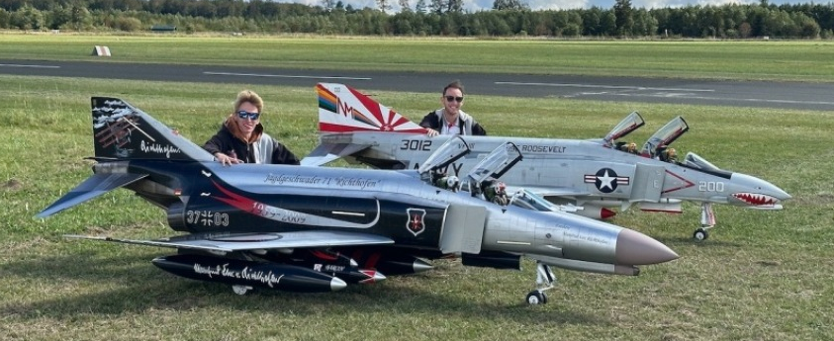

A GOOGLE search for ‘CARF F4’ will give all information on these spectacular models.

Have You paid Your Subs Yet? Please make payment to the Branch Account
Royal Aeronautical Society 11-6900-0018393-11
October BRANCH MEETING
At our usual venue – the Massey School of Aviation.
Meeting at 1900 Tuesday 14th October.

This month our meeting will be a ‘game of two halves’

First Stephen Parsons and I will present our thoughts on the branch’s representation to the Palmerston North Airport on what we think should be displayed in the new terminal. Stephen developed an overall plan for displays and we then focussed on our part and on this we want the Branch members’ input.

Following on, Member Warwick Jones will give a presentation on the M/D Skyhawk A4K & TA 4K as operated by 75 Sqdn. at RNZAF Base Ohakea from 1970-2001.

Warwick is ex Chairman of the Hamilton Branch of the Society, and was service crew at RNZAF Base Ohakea. He worked on these aircraft for the first 4yrs, 70-74, as an engine mechanic and did the Vanguard exercises to Singapore, 71-73, Vanguard 15, 16 and 17, and one to Darwin in MayJune/73 called operation Blue Denim, alongside the RAAF Mirages and RAF Vulcan B.2's. He will cover the deployment details, operations and will have a slide show during the talk.

Join us for a coffee after the meeting,
Maurice Job,
Branch Chairman
mauricej@inspire.net.nz
Phone (021) 670689



