FLY BY
September 2025 NEWSLETTER of the PALMERSTON NORTH BRANCH NEW ZEALAND DIVISION ROYAL AERONAUTICAL SOCIETY
______________________________________________________________________

At our August Branch meeting we had a very informative presentation from David Lanham; CEO of the Palmerston North Airport Company. David described the development of the terminal building and the context in which it was designed. Quite notably is that there is neither planning or expectation of Palmerston North getting international traffic. As he said, three trips to Brisbane per week or act as a feeder to the likes of Wellington or Auckland for many international flights per week to all parts of the Pacific and beyond.

David has asked the Branch for ideas for displays in the new terminal building. While floor space will be at a premium, ideas for wall displays will be welcomed. The Branch has some historic material which may be used, and other ideas can be discussed at a Branch meeting in the future.,

Branch member Glen Turner presented the new book “Courage Aflame” which is the story of Sgt Pilot James Ward VC. Ward received his medal after climbing out of his Wellington bomber on to the wing and extinguished an engine fire. The book is available for $40 as below from Glen.
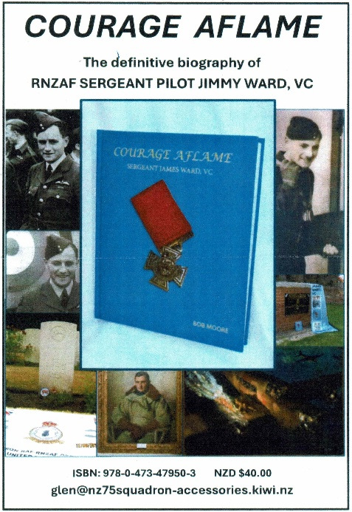

The Branch has also purchased the book for raffle purposes. To cover the purchase cost of the book, raffle tickets will be increased to $4. Get yours at the meeting.

For ‘Sale’
I still have in my garage a screen (no projector) and stand and a pair of small speakers with an inbuilt amplifier. These can be obtained for a reasonable offer to Branch funds. Please contact me.

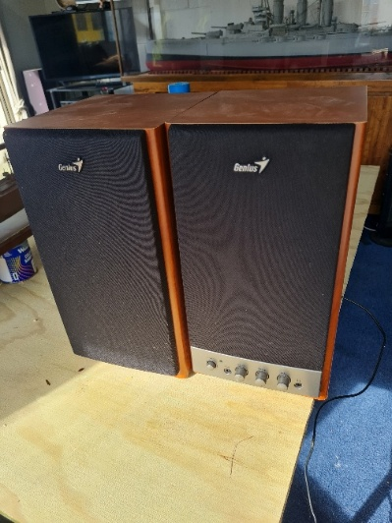

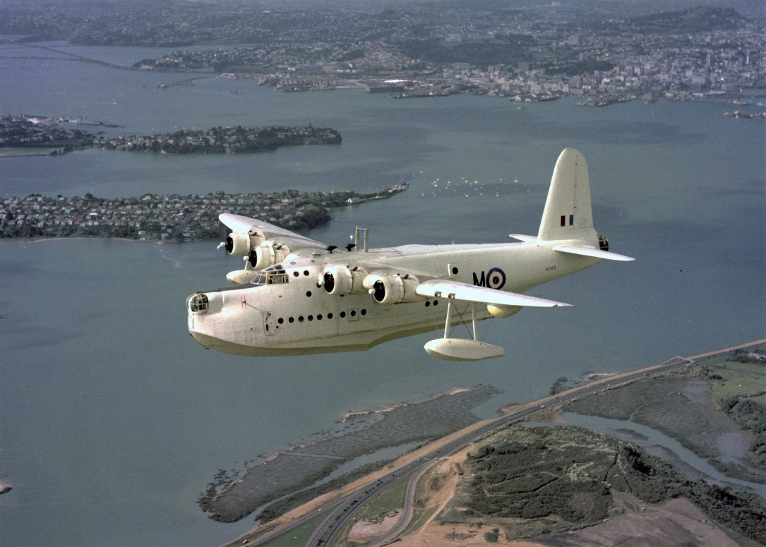

Have You paid Your Subs Yet? Please make payment to the Branch Account
Royal Aeronautical Society 11-6900-0018393-11
September BRANCH MEETING
At our usual venue – the Massey School of Aviation.
Meeting at 1900 Tuesday 9th September.

Our September Branch Meeting will be addressed by the redoubtable Hugh Francis. Squadron Leader (rtd) Hugh Francis; ex- RNZAF Navigator and Staff Officer has over the years given presentations on the Sunderland Flying Boat, Bristol Freighter; and, Hercules aircraft which he has navigated. This presentation will be about the History of RNZAF Flying Boats; his personal experiences and stories; and, the equipment used for navigating around the Pacific region.
In preparation for his presentation, Hugh has sent this link which is for a video on the Battle for Tarawa, which makes worthwhile viewing to put his address into perspective.

https://www.youtube.com/watch?v=pz5krwz9iFk.

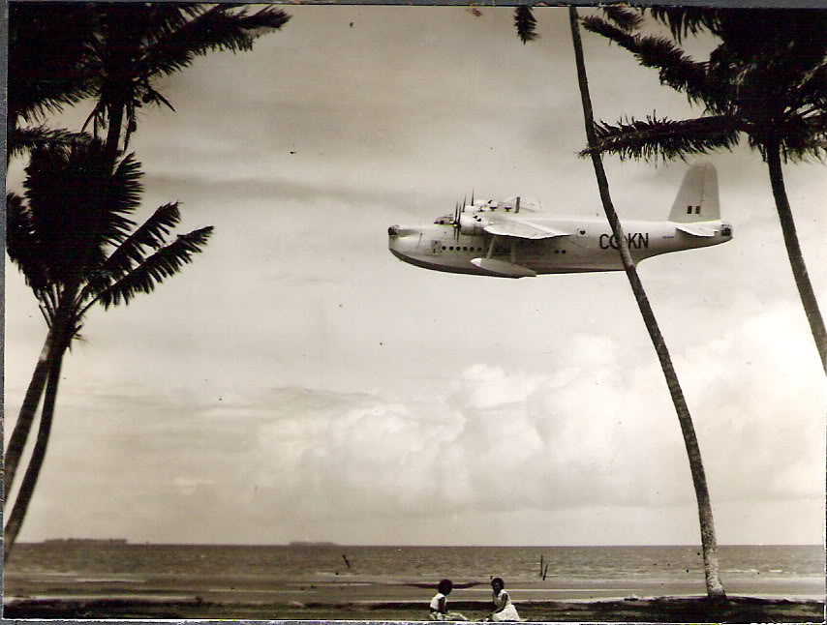

Join us for a coffee after the meeting,
Maurice Job,
Branch Chairman
mauricej@inspire.net.nz
Phone (021) 670689

