FLY BY
November 2025 NEWSLETTER of the PALMERSTON NORTH BRANCH NEW ZEALAND DIVISION ROYAL AERONAUTICAL SOCIETY
______________________________________________________________________

Our October meeting was brought up to date on the thinking with regard to the Branch’s interest in the development of the terminal. We are keen to see a strong remembrance of the history of Milson and the prominence of the airfield in the history of Civil Aviation in New Zealand. We are keen to have the role of the RNZAF in the region also recognised. Discussions are continuing between the branch, in the person of Stphen Parsons and the airport company.

The following is Steve Parsons’ report back to us:

The meeting was held on the 24th of October. 2025 with David Lanham. We discussed the historic elements of Palmerston North airport. The meeting was in response to David's challenge on how airport history can be incorporated into the new airport development.

The airport company is open to what is needed at this time and is well-positioned to incorporate historical elements into the critical interior design.
What and how it looks will be part of an ongoing conversation.
.
The challenge at this time is designing the airport interior to work for both customers and the airport.

I was able to provide a draft document with thoughts on presentation via an electronic format. Not only on a big screen but also on the airport website and social media

Photos of some historic items in storage are below.

We must keep in touch with Dave and support the airport's development.

Steve

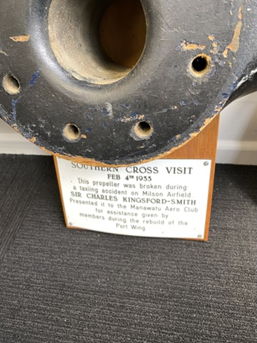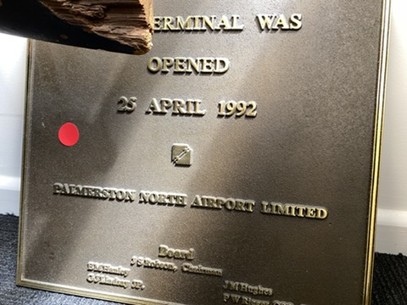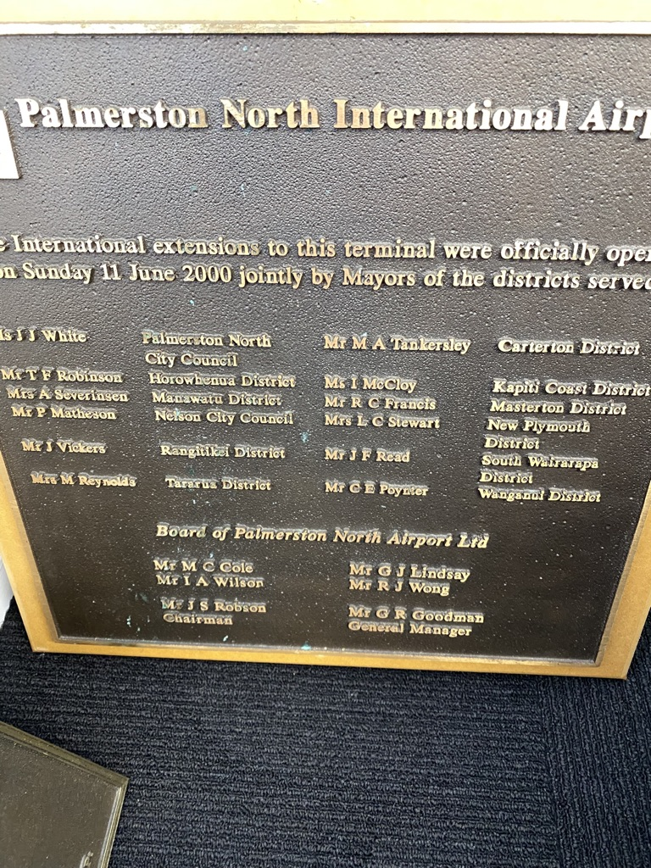

Following Stephen’s presentation our member Warrick ‘Flea’ Jones gave us a very detailed and interesting discourse on the McDonnell Douglas A4 Skyhawk in RNZAF service, from the perspective of the ground crews who worked hard to keep these aircraft not only in service on a day to day basis, but in exemplary condition up to the point that they were sold.

After Warrick’s talk, Frank Sharp acknowledged the efforts of the servicing personnel, from a pilot’s perspective.
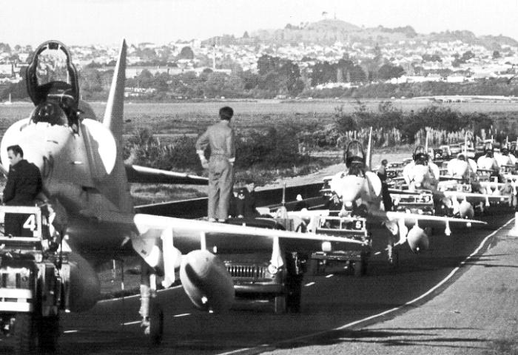
Skyhawks being delivered to Whenuapai by road (RNZAF photo)

The AGM of the NZ Division of Royal Aeronautical Society will be held on December 4th. The current President is standing down and a number of Council members will be up for re-election as their term comes to an end.
Which brings me to our own Branch AGM in February! Anyone wishing to become involved in the running of this Branch please come and talk to me, all positions are up for nomination as always.
Due to the lack of interest, we will not be holding an ‘end of year’ dinner this year. Having said that, if there is an outpouring of support for such an event, I will try to organise something, but time is getting short!
November BRANCH MEETING
At the Massey School of Aviation.
Meeting at 1900 Tuesday 11th November.

This meeting our guest speaker will be Ashok Poduval, Chief Executive of Massey School of Aviation. Ashok has been a training Captain with Indian Airlines and Gulf Air and has over 12500 hours of airline jet flying experience. He has held corporate positions with IATA and Gulf Air and is a frequent international presenter and consultant. He has this year been appointed as President of Aviation New Zealand and is a Fellow of the Royal Aeronautical Society.

Coffee and tea available after the meeting, this is a pleasant way to finish off the evening with informal chatter, so do make the most of it.
Maurice Job,
Branch Chairman
mauricej@inspire.net.nz
Phone (021) 670689

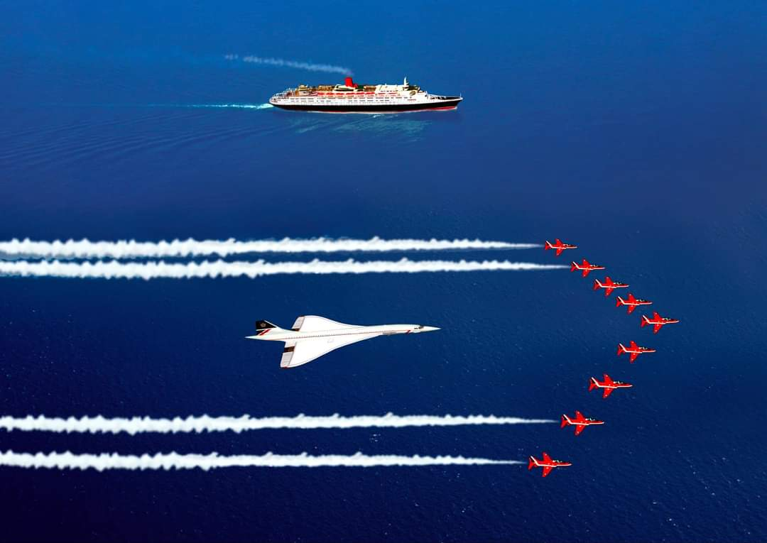
This photo took an enormous amount of coordination to get the Concorde service in place with the QE-II and the photographer in a Tornado fighter at the same time and place

