FLY BY
November 2025 NEWSLETTER of the PALMERSTON NORTH BRANCH NEW ZEALAND DIVISION ROYAL AERONAUTICAL SOCIETY

Ashok Poduval, our host at Massey School of Aviation, gave us something to think about at our November meeting. He addressed the issues accompanying a shift from open “Just Culture” of no blame, to a more aggressive liability based culture within civil aviation authorities. His concern is that this shift will result in a less constructive atmosphere toward resolving issues and incidents within aviation.

This month many will have seen the German Luftwaffe’s Airbus A400M transports in our skies, both nationally and in the Manawatu region. Performing low level supply missions, three flew very low through our vision at Feilding giving us a great view of this competitor for the mighty Hercules.

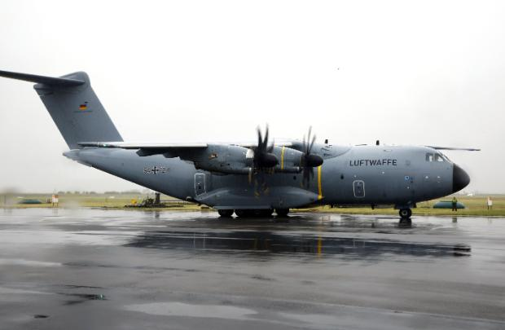
Photo courtesy NZDF

Branch AGM is coming

December BRANCH MEETING
NO MEETING
Tuesday 9th December.

Due to the low level of interest in an ”End of Year Dinner” the November meeting agreed to an informal meeting for December.
However, Massey themselves will be using the facility on the evening of our meeting. In view of the short time to organise an alternative, the December meeting is cancelled.

Our next meeting will be Tuesday 10th February 2026

Maurice Job,
Branch Chairman
mauricej@inspire.net.nz
Phone (021) 670689
I would like to wish all Branch Members and Families a joyous Christmas Season and Prosperous 2026!


