FLY BY
February 2026 NEWSLETTER of the PALMERSTON NORTH BRANCH NEW ZEALAND DIVISION ROYAL AERONAUTICAL SOCIETY

Welcome back everyone, I trust you all have had a good break, despite the weather and the disasters that seem to happen all around. Fortunately, Manawatu has had it pretty good, all considered.
I spent the start of the year away doing admin work at the Model Flying NZ Nationals in Hawkes Bay. This year we were fortunate in getting great weather and there was some great competition in all disciplines. Total immersion in the hobby is great, but you come home pretty exhausted. However, I now have two big gliders and a ¼ scale SE5A ready for test flying.

The year starts off with our Annual General Meeting. The notice of this meeting is later in this FlyBy.
Raffle
Last year we decided to operate the branch monthly raffle a bit differently. I for one do not carry coins so am unable to buy tickets on that basis. It was agreed that pre-purchase of a year’s worth (10) tickets would be available. This will be done as follows
- When subs reminders are sent out there will be an option to pay 10 draws times $2, additional for the tickets. You can buy more than one number at $20 each
- Jeff will be given a sheet with numbers and randomly allocated names as they are paid which he will be able to add to.
- That number will be your tickets for the year
- If you are not present at a meeting, your number remains in the draw and you will be notified
- If you attend a meeting, you may have a second number at no charge
- You will be able to purchase tickets on the night as well.
- Based on this last year’s membership, there will be 50 numbers on the sheet

Secretary Barry Heir writes:
WINGS PRESENTATION CEREMONY ,MASSEY SCHOOL OF AVAITION.11 TH DECEMBER 2025

I had the pleasure to go along on behalf of our local branch of the Royal Aeronautical Society.(Palmerston North BRANCH awards).
On the 11th of December 2025 at the Globe Theatre.
I have been several times before and it is always great to see these young Students receiving rewards for the hard work they have put in for their year.

Frank Sharp is the Director of the Programme and Ashok Poduval does the closing Presentation at the end .

Barry Heir
Palmerston North Branch of the Royal Aeronautical Society,

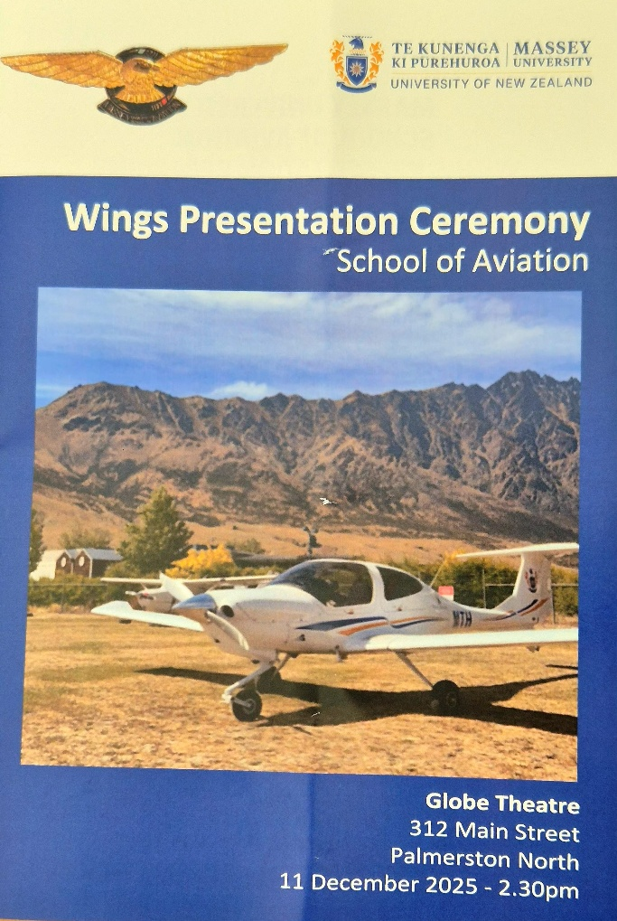

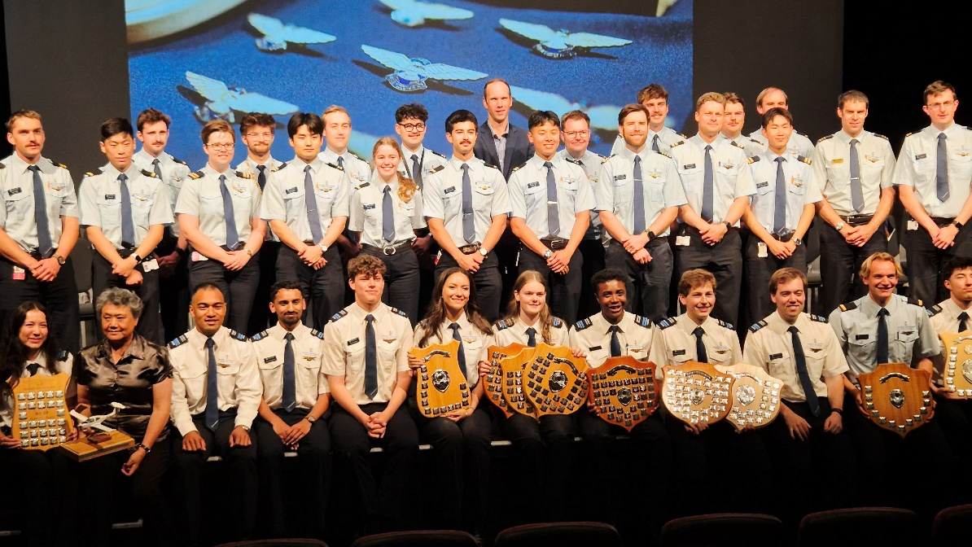
BRANCH ANNUAL GENERAL MEETING
Tuesday 10th February 7.30PM
Massey School of Aviation
Airport Drive, Palmerston North

Agenda:
- Brief report by Branch Chairman
- Presentation of Balance sheet
- Election of Officers
  - Chairman
  - Secretary
  - Treasurer
  - Proposed addition of up to two Committee members
- Confirmation of Honoraria to Officers, plus Honorary membership to Raffle Organiser.
- General Business

Coffee or Tea afterward, please join us
Maurice Job,
Branch Chairman
mauricej@inspire.net.nz
Phone (021) 670689

