FLY BY
March 2026 NEWSLETTER of the PALMERSTON NORTH BRANCH NEW ZEALAND DIVISION ROYAL AERONAUTICAL SOCIETY

Our AGM was held in February and attended by 26 Branch Members, thank you who came and participated. Salient points from the meeting include;

- Committee re-elected; Chairman Maurice Job, Secretary Barry Heir, Treasurer Roger Martin
- Two additional committee can be seconded if the officers feel the need
- Subs remained at $20
- Raffle to be available on a $20 for 10 tickets basis plus ‘cash on the night’
- Branch finances are sound, but our commitments to Massey and ATC No32 Squadron mean they will have to be managed carefully.

Attached with this Flyby you will find the minutes of the AGM, from Barry Heir.

The raffle cost can be paid directly, and subs, to the Branch Bank account

11-6900-0018393-11

Please include your name, and “Subs” or “Raffle” in your deposit.

When you have paid for your raffle numbers, talk to Jeff and pick your number(s) for the year. Your number will be entered in the draw every month. If you are attending a meeting, you can buy additional numbers for that evening’s draw.

We note this month the Passing of long term Branch Member Bill Tillick, our thoughts go out to his family.

Saturday March 28th and Sunday 29th is the Palmerston North Aeroneers Model Aero Club Annual Rally for model aircraft. This is held at the Club’s flying field on Spur Road West, flying will commence around 9.30am on both days. This is a rally so while there is no formal program, we will try to keep planes flying all the time.

Follow Spur Rd West toward the river, the gate is sign posted. The lane to the field is one-way so care is needed. The gate into the field for parking is about 390metres from the road.
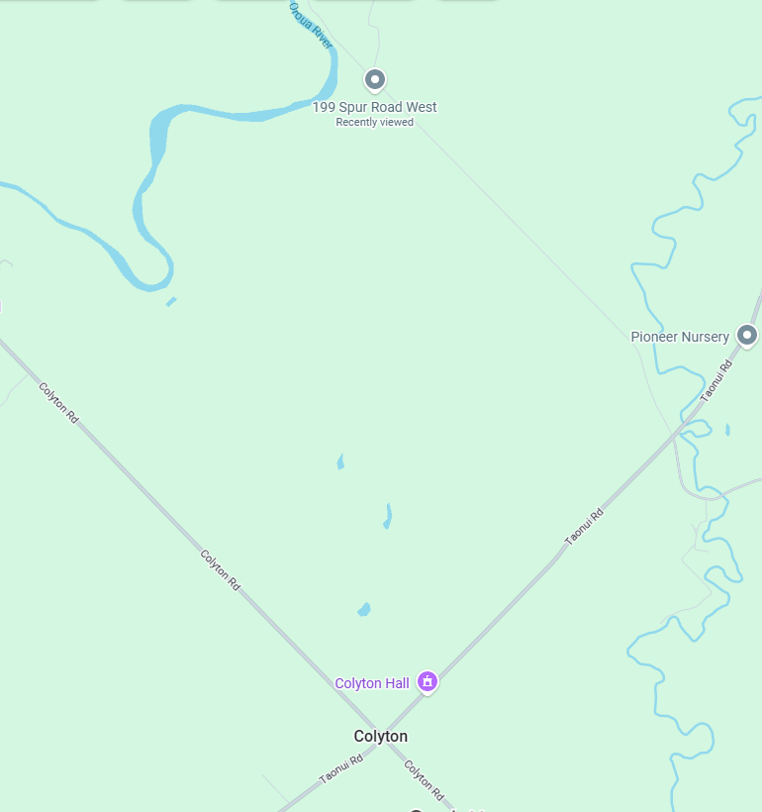
Aeroneers field on Spur Rd West

Subs for 2026 are Now Due!

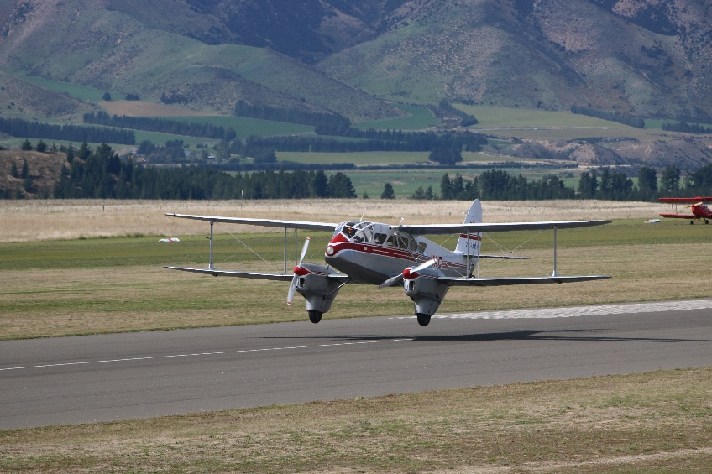
ZK-AKY at Wanaka

MARCH BRANCH MEETING
Tuesday 10th March 7.00PM
Ohakea War Memorial Aircraft Collection
Ohakea War Memorial Hall, Speedy Road, Ohakea

This month we will be visiting the OWMAC Museum in the Ohakea War Memorial Hall on the corner of Speedy Road and Tangimoana Road, near Ohakea.
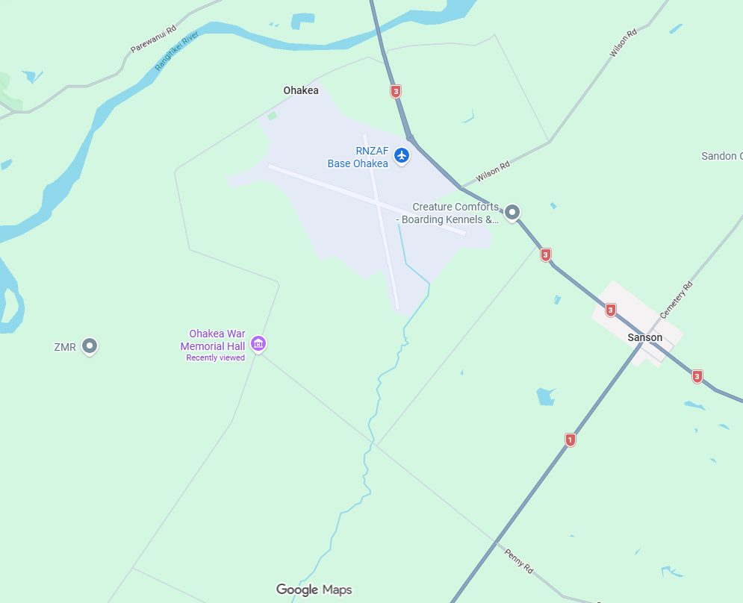
OWMAC location Map

Note the earlier start time of 7pm which we think will make the best use of the daylight savings.
From the Bulls direction turn down Tangimoana Rd just after the river bridge. From Feilding or Palmerston North, turn down SH1 at Sanson and then right into Speedy Rd.
The team will be able to show us through their extensive collection of RNZAF memorabilia, in particular as they relate to Base Ohakea.

Maurice Job,
Branch Chairman
mauricej@inspire.net.nz
Phone (021) 670689

