FLY BY
April 2026 NEWSLETTER of the PALMERSTON NORTH BRANCH NEW ZEALAND DIVISION ROYAL AERONAUTICAL SOCIETY
We had a great visit to OWMAC for last month’s meeting. There is certainly a huge collection of RNZAF material, focussed on Ohakea and its history. Thanks to Mike and Greg for their hospitality and for sharing their knowledge and passion.

It is noted with disappointment that all military aircraft have been withdrawn from this year’s “Warbirds Over Wanaka” due to the delicate state of the world at present. The highlight was to have been the American F22 Raptor Display Team but these planes and the people who operate and support them have become otherwise occupied, and RNZAF involvement has been similarly diverted. I am sure the airshow will however be worth the trip for those who make it.

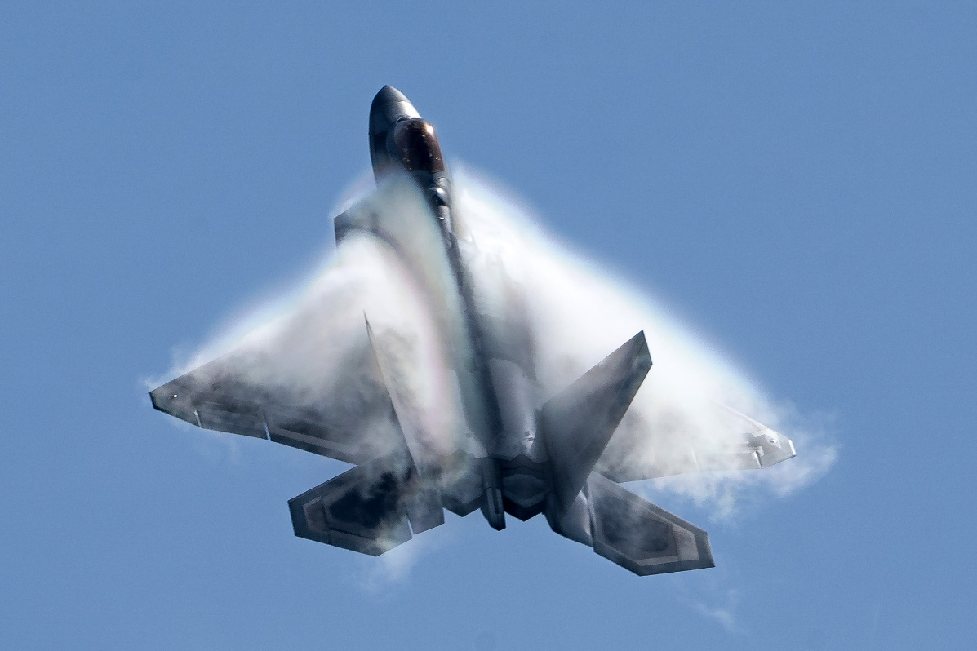
Image from USAF

We note this month the Passing of Branch Member Kevin O’Connor, our thoughts go out to his family.

APRIL BRANCH MEETING
Tuesday 14th April at 7.00PM
Massey University School of Aviation
Airport Drive, Palmerston North
___________________________________________________________________

This month let’s revisit the Models theme as we have a number of members who are very busy creating models of many things with an Aviation theme. Those members who visited OWMAC last meeting would have seen the fine diorama and models of aircraft with Ohakea history

Bring along your creations and perhaps give us a brief outline of its story.

Maurice Job,
Branch Chairman
mauricej@inspire.net.nz
Phone (021) 670689
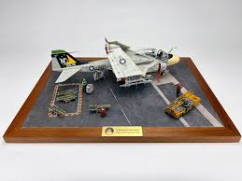
Image courtesy IPMS Auckland
Subs ($20) for 2026 are Now Due!

The subs, and raffle cost can be paid directly, to the Branch Bank account

11-6900-0018393-11

Please include your name, and “Subs” or “Raffle” in your deposit.

