FLY BY
August 2026 NEWSLETTER of the PALMERSTON NORTH BRANCH NEW ZEALAND DIVISION ROYAL AERONAUTICAL SOCIETY

Winter is surely upon us now, the fairly gentle weather we have had for the past while is definitely changed with the current polar blast driving temperatures through the floor. I trust everyone is able to stay warm and secure.

I have been very busy with modelling projects which culminated in an excellent weekend of gliding near Te Aroha in the Waikato. Also, I am beginning the organising of a Hobbies show in PN next April, which promises to be very successful, but a lot of work.

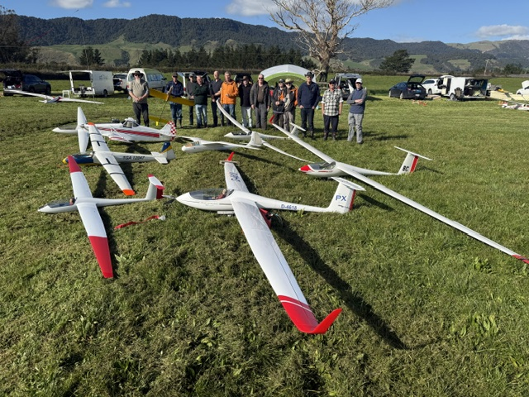
Model gliders at Te Aroha, including the tow plane (pic courtesy Bill Derenzy)

The July Branch meeting was educated and amused by Major Mike Pettersen’s history of Atomic testing in Australia. Mike became the NZDF representative and expert on matters CBRNWMD or Chemical, Biological, Radiological and Nuclear Weapons of Mass Destruction. What struck me from his presentation was the arrogant attitude and disregard for both the servicemen who had to witness the tests, and the indigenous peoples of the regions that were used for testing, both were just considered test subjects and collateral damage. This callous attitude apparently originated in the UK Government who inflicted it on the Australian Government, giving the latter no say in the decisions that were made. He also noted the long term legacy of the testing in the landscape and people of South Australia.

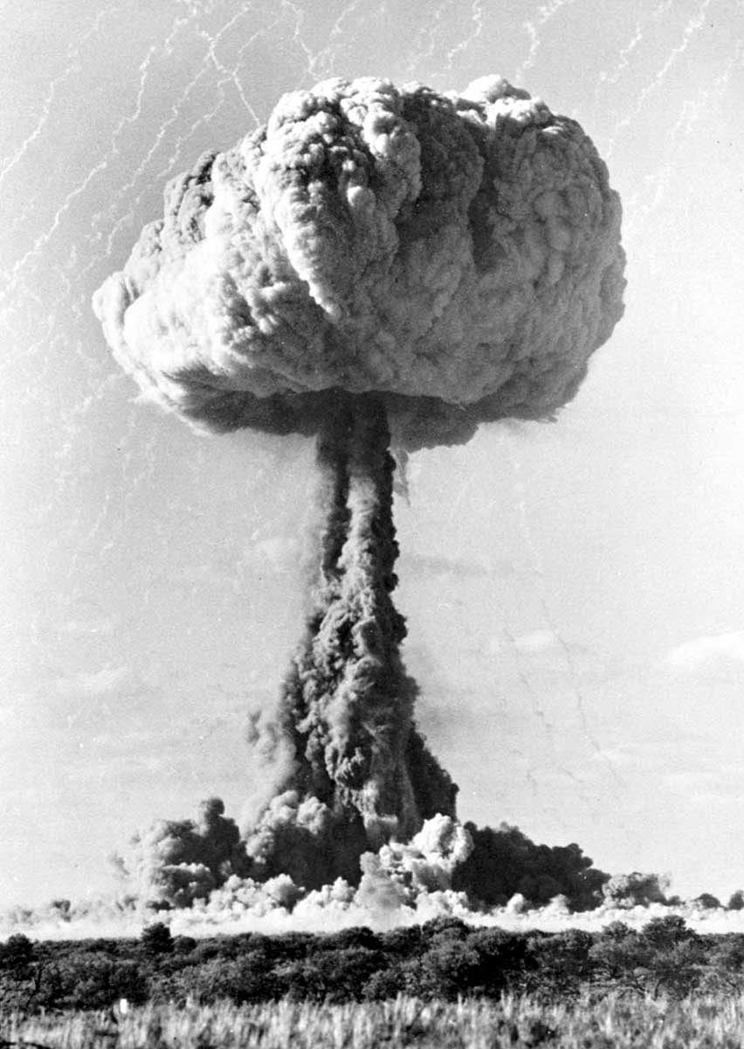
An image from Maralinga atomic testing

August BRANCH MEETING
Tuesday 11th August at 7.00PM
Massey University School of Aviation
Airport Drive, Palmerston North
___________________________________________________________________

Our August Branch meeting will be entertained by our own world travelling Secretary Barry Heir who will be talking about his visit to the Shuttleworth Air Show in May. The collection is at Biggleswade North of London. Also his trip to The New Zealand Liberation Museum ‘Te Arawhata’ in Le Quesnoy in France and the history that I have learnt about the connection with New Zealand.
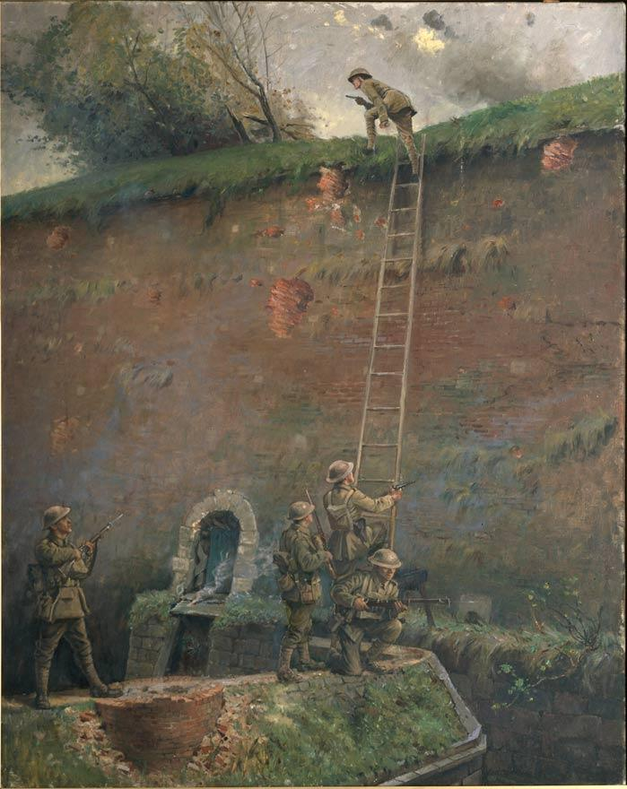

We look forward to seeing you at the meeting and sharing a cup afterward

Maurice Job,
Branch Chairman
mauricej@inspire.net.nz
Phone (021) 670689

